TRAVEL PLAN FOR SHINFIELD PARISH
OCTOBER 2021

INDEX
PAGE NUMBER
- Introduction 2
- The Shinfield Context 3
- Geography 4
- Travel Policy Objectives 4
- Residents Needs 4
- Public Transport 6
- The Challenges 6
- Wokingham Plans for Cycle Ways in Shinfield Parish 7
- Gaps between Shinfield Parish Council and
Wokingham Borough Council Assessments 7
- Proposals by Shinfield Parish Council to improve
Cycling and Walking around and through Shinfield Parish 8

Appendix 1 10
Appendix 2 11
Appendix 3 12
Appendix 4 13
Appendix 5 14

- INTRODUCTION

Shinfield Parish Council has developed a policy to encourage Cycling, Walking and the Use of Public Transport within Shinfield Parish. The purpose of the policy is to inform Wokingham Borough Council, Reading Borough Council and developers when developing travel proposals that affect the Parish.

In 2021 the United Kingdom hosted the COP26 meeting to further the worldwide carbon emissions reduction strategy. In this context, Shinfield Parish Council is developing a range of measures to reduce carbon emissions including renewing buildings with lower carbon footprints, using electric vehicles and encouraging alternatives to fossil fuel-based car travel through negotiating improvements to the local bus network to make services more usable and working with partners to improve knowledge and use of walking and cycling routes (Appendix 3).

- THE SHINFIELD CONTEXT

Shinfield Parish includes the South of the M4 Strategic Development Plan, leading to a forecast population growth from 11,000 to 19000 persons by 2025 which is a population increase of 8000. At current levels of vehicle usage local road use is likely to grow by approximately 4000 vehicles with little further improvement planned to infrastructure

The parish acts as road transport funnel for vehicles travelling to the M4 at Junction 11 and to Reading from Hampshire via the A33 dual carriageway, South Wokingham and the West Surrey via the two lane A327. In recent years the majority of traffic on the A327 has been diverted onto the Eastern Relief Road away from residential areas. However, traffic aiming for Junction 11 of the M4 cuts through the villages along the narrow Hyde End Road and Church Lane routes rather than using the B3270 along the north side of the M4.

Reading Borough Council has developed a strategic cycle route alongside the South Reading Bus Rapid Transport (BRT) route along the A33 from the south side of the M4 into the town centre and is planning a Cycle Way from Shinfield Rise into Reading starting at the northern edge of the parish.

- GEOGRAPHY

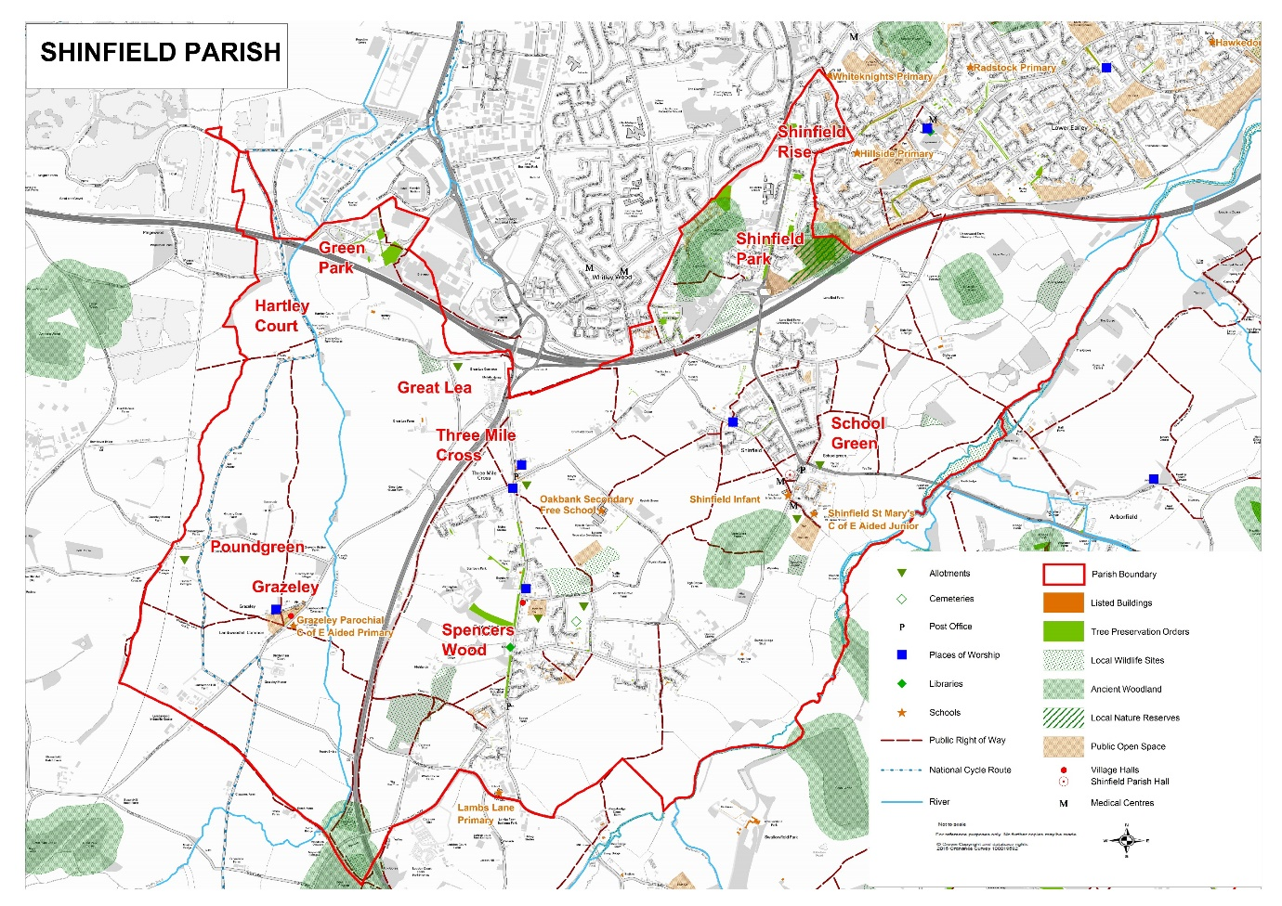
Shinfield Parish is located to the south-east of Reading and in the west of Wokingham borough.
The parish consists of three major geographic areas with significant differences in accessibility:

- North: Shinfield North is the part of the parish north of the M4 which is an urban extension of South-East Reading. The area has a main road linking it with south of the parish and Reading town centre and will have connections to the main cycle route from Reading to the University and Shinfield Rise as well as a number of quieter roads. It is linked to Junction 12 of the M4 and has good urban bus services and is within the Reading fare zone.
- South: Shinfield, Spencers Wood and Three Mile Cross and the South of M4 Strategic Development Location contains the major part of the parish population plus the Shinfield Studios and University Science Park. By 2022 the area will also include five primary age schools and one secondary school. The area is bounded by the M4 to the north, the River Loddon to the south and east and the A33 Swallowfield Bypass to the west.
Internally the area has two north-south roads and two east- west roads and a series of quiet lanes and By-ways linking the communities as well as an east -west sustainable transport link for buses, cyclists and pedestrians. The area has limited crossing points for cars and cyclists with two main road crossings of the Loddon and also a By-way and another quiet lane for cyclists. There are only two road crossings and two further foot and cycle crossings of the M4 and only two road crossings of the A33.

- West: West of the A33 to the Basingstoke - Reading Railway line (the approximate border of SHINFIELD PARISH COUNCIL and Wokingham BC) there are a network of quiet lanes and By-ways suited to walking and cycling. The area also contains a road link across the M4 to the new Reading Green Park Station and to the Kennet riverbank footpaths. The road is part of the Round Berkshire Cycle Route. The area has a small population and is part of the Burghfield Detailed Evacuation Planning Zone (DEPZ) and is likely to remain relatively undeveloped farmland.

Geographic and administrative definitions

Shinfield North is coterminous with parish and borough ward boundaries. Shinfield South and West areas are coterminous with all other parish wards and includes Shinfield South and part of Swallowfield borough council wards. The use of north, south and West in this policy relate to definitions in paragraph 3 (a, b, c).

- TRAVEL POLICY OBJECTIVES

Shinfield Parish Council Travel Policy objectives are to provide a safe environment for residents and visitors to meet their daily travel and leisure requirements by walking and cycling though:

- A connected and linked network of walking and cycling routes along quiet roads and dedicated off road routes.
- Provision of such walking and cycling that go where people need and want to go.
- Segregated and protected walking and cycling spaces on busy roads where alternative routes are not available.
- Reduced speed limits on all roads shared by cyclists and motor vehicles.
- Connections to a wider network of segregated routes to Reading, Lower Earley/Winnersh Triangle and Arborfield.
- Increased access across the A33 to the west of the Parish including to the Mere Oak Park and Ride, Reading Green Park Station and the River Kennet for leisure, school and work journeys.
- Provision of new segregated routes that are safely shared between walking and cycling.
- Retaining the character of our quiet lanes.
- Improving access to Public Transport
- Improving road safety
- Improving availability of information on sustainable travel options for local travel

- RESIDENTS NEEDS.

The Strategic Housing Market Assessment (2008) indicated that the majority of residents work outside of the parish. This may change with the advent of the Science Park and Film Studios. The majority of Primary Age children are educated within one of the local schools (5 existing and 1 planned) whilst secondary school pupils are educated at the local Oakbank School or at schools in Arborfield, Reading and Wokingham.

Each major village has a fuel garage, vehicle repair garage, sub-post office and at least two convenience stores whilst a larger store is planned for School Green. The area has a baker, a butcher, flower shops, hair-dressers/barbers, 5 open Public Houses, and a garden centre. The villages are separated by green wedges and Suitable Alternative Natural Greenspaces (SANG) so they are not close enough for all travel between the villages to be walkable but are close enough to be within cycling distance.
However, within the individual villages all residences are within walkable distance of local facilities.
Residents in Shinfield North are within walking distance of local facilities in Whitley and Shinfield Rise within Reading borough.

The largest local travel activities are split between local journeys within the parish and journeys to facilities which serve residents outside the parish:

- To shops and business services
- To schools
- To health services
- To the SANGs, sports and recreation facilities
- To Reading for Work, Onward Travel by Bus or Rail

Local travel activities with accessibility within or from outside the parish

 |  | Location |  | Accessibility
ID | Destination | Within Parish | Outside  Parish | Walking route | Cycling route | Bus service | Car access
S01 | Local Shops, business services | YES |  | YES | YES | NO | YES
SO2 | Large shops, businesses etc | NO | YES | NO | NO | YES | YES
E01 | Primary Schools | YES |  | YES | YES | NO | YES
E02 | Secondary Schools | YES |  | YES | YES | NO | YES
E03 | Secondary Schools |  | YES |  | NO | NO | YES
EO4 | University of Reading Whiteknights campus |  | YES | NO | NO | YES | YES
H01 | Local Health services (Shinfield) | YES |  | YES | YES | NO | YES
H02 | Local Health services (Swallowfield/ Whitley) |  | YES | NO | NO | YES | YES
H03 | Hospital services (Royal Berks) | NO | YES | NO | NO | YES | YES
R01 | Green space and SANGS | YES |  | YES | YES | NO | YES
R02 | Sport facilities/fields | YES |  | YES | YES | NO | YES
R03 | Recreation/community facilities | YES |  | YES | YES | NO | YES
W01 | Work at Science Park/Film Studios | YES |  | YES* | YES | YES* | YES
W02 | Work in greater Reading |  | YES | YES** | YES | YES | YES
W03 | Onward travel by rail*** or bus | YES |  | NO | YES | NO | YES
WO4 | Onward travel by rail or bus**** |  | YES | NO | YES | YES | YES
*From Shinfield and Shinfield north
**South Reading
***Following opening of Reading Green Park Station and restart of National Express coach services from Mere Oak Park and Ride.
****Reading Station

The largest travel flows for employment are to South Reading, University of Reading and inwards to the Science Park/Film studios.

- PUBLIC TRANSPORT

- Reading bus services 3 & 8 provide a frequent bus service to and from the East of the Parish
Mereoak Park & Ride provides a frequent service into Reading.
- Park and Ride services stopping at Hartley Court Turn (A33 Bus gate) provide frequent services to Reading town centre and station for Three Mile Cross residents.
- Service 9 from Fullbrook Avenue does not stop along a considerable section of Hyde End Road restricting access to local residents. Plans are being evaluated for 3 additional stops on this section.
- Service 7 from Spencers Wood to Reading has timetable gaps in service of up to 2.5 hours.
- Service 7 has a restricted service south of Spencers Wood to Swallowfield and Fleet which limits public transport access to Swallowfield Medical Practice.
- At times the route 7 & 9 timetables coincide along the Basingstoke Rd from Spencers Wood to/from Reading limiting the benefit of the additional capacity and sustainability of route 7.
- Services 8 & 9 form a circular route but ticketing ends at Fullbrook Avenue where route numbers and destination boards are changed. Significant local benefit would be created by merging the two routes into a single service provided by the same vehicle with through ticketing to give additional direct links to Reading destinations (Reading Station, town centre, Royal Berkshire Hospital), between Spencers Wood/Three Mile Cross and medical facilities in School Green and employment at the Science Park/Film studios.

- THE CHALLENGES

- For residents of the south area internal walking routes are generally well-defined and road crossings generally well protected. An exception is the crossing of Hyde End Road at the western end of Shinfield when all pedestrians must cross from the north to the south of the road at a location with poor visibility. Certain roads require improvement such as Church Lane between the Six Bells and Shinfield Church which is increasingly busy and lacks any segregated footway to permit residents to walk to the M4 footbridge from the residential areas.

- Cyclists lack a connected route to the A33 cycle way as the pavement between Three Mile Cross and the A33 is only suitable for pedestrians and the road is very busy and narrow. An alternative route through the new estate north of Church Lane requires an improved cycle and walking connection to the A33.

- Within the south area cyclists should be directed to the sustainable transport link and internal cycle routes to keep them away from Church Lane and Hyde End Road. However, work is required to complete a suitable link from Fullbrook Avenue to Church Lane.

- A key cycle link exists along Cutbush Lane and links to the Lower Earley Way cycle lane. However, there is a gap for cyclists traveling to the University and Royal Berkshire Hospital along Shinfield Rd which need to be resolved. This also affects residents and visitors from Reading travelling to the Science Park/Film Studio. The M4 footbridge and Black Boy bus lane bridge provide exits from the south area but do not link to suitable routes into Reading.

- To the east there is a gap to Arborfield which should be resolved within the Wokingham Borough Council plan.

- Shinfield Parish Council has developed a map of cycling and walking routes which are publicised on the Parish website. This required wider broadcasting should be included in links from Wokingham’s website.

- WOKINGHAM PLANS FOR CYCLE WAYS IN SHINFIELD PARISH

Shinfield Parish is connected to the Wokingham Borough Council cycle routes:

- Wokingham, Winnersh, Earley and Reading (Routes CR3 and CR5) which connects with Cutbush Lane and serves the North and South area of the Parish providing segregated access to Earley and Winnersh Triangle.
- Beech Hill to Green Park is linked by CR4 through the west of the Parish but is disconnected from the populations of the South Shinfield Area.

The Wokingham Draft Plan aims to provide a safe network of cycling and walking routes between the towns and villages of Wokingham Borough.

Wokingham is developing a programme of Greenways, including route A to link Arborfield Cross with South Shinfield and the Loddon Long Distance Path. The route connects with Cutbush Lane and the Black Boy roundabout bus lane and provides a link through Greenway route F to Arborfield Garrison (Bohunt School) and through Route B to Wokingham and Emmbrook (Emmbrook and The Holt schools).
The new Hatch Farm spine road links to the lower Earley Way Cycle Route and provides another segregated cycle way to connect with the A329 cycle route (Forest School).

The proposed Loddon Long Distance Path is supported by the Shinfield Neighbourhood Plan to provide walking access along the north bank of the river Loddon.

- GAPS BETWEEN SHINFIELD PARISH COUNCIL AND WOKINGHAM BOROUGH COUNCIL ASSESSMENTS

- The routes proposed within Shinfield South in the draft plan are existing roads that are narrow and carry high levels of vehicular traffic and are considered by Shinfield Parish Council to be unsafe for cyclists.
- No infrastructure improvements are proposed to improve cyclist safety.
- The proposals do not provide segregated routes through the south of Shinfield between Spencers Wood and Three Mile Cross and between Spencers Wood and Shinfield and propose that cyclists continue to use the busy unsegregated Basingstoke Road and Hyde End Road

- PROPOSALS BY SHINFIELD PARISH COUNCIL TO IMPROVE CYCLING AND WALKING AROUND AND THROUGH SHINFIELD PARISH

Existing proposals and obligations

Existing proposals and obligations by developers, Wokingham Borough Council and Shinfield Parish Council should be completed:
1) Three Mile Cross Junction Improvement works with associated cycle way and foot path from Basingstoke Rd via the Parklands development and Deer Leap Park to Hays Drive roundabout to be completed.
2) Footways in sports fields west of Hyde End Lane to be completed connecting Fullbrook Avenue development with Ryeish Sports Hub and Oakbank School. Implement school zone safety measures around Oakbank School.
3) Publishing Wokingham Borough Council and Shinfield Parish Council Walking, Cycling and Bus information and maps on the Shinfield Parish Council website, notice boards, within community buildings and providing promotional material and weblinks to local schools and employers.
4) Wokingham Greenways routes A, B &K and Loddon Long Distance Footpath plans to be implemented.
5) Implementing 3 additional bus stops on Hyde End Road between Basingstoke Road and Fullbrook Avenue.
6) Implementing speed limit reductions and village gates on all main routes within Shinfield Parish to protect cyclists and pedestrians (see Appendix 4).

New proposals
New proposals by Shinfield Parish Council aim to improve the Draft Wokingham plan.

Proposal 1: Church Lane segregation
Build a cycleway/footway along or parallel to Church Lane from St. Mary’s Church to the Six Bells Public House to connect with the M4 foot and cycle bridge to link north Shinfield and South Shinfield.

Proposal 2: Three Mile Cross Cycle Route.
Provide a segregated cycle route from Swallowfield and Spencers Wood to Three Mile Cross and the A33 Cycleway via either Lambs Lane, White House Lane and Woodcock Lane or segregated lanes on Basingstoke Road.

Proposal 3: Hyde End Lane segregation
Provide a walking and cycling route east of and parallel to Hyde End Lane from the Fullbrook Avenue Bus Gate to the Mays Farm SANG car park and Church Lane.

Proposal 4: Shinfield North Cycle route to Shinfield Rise
Create a cycling/walking path from the Black Boy roundabout northwards to link with the Reading Borough Council Cycle lane at Shinfield Rise to provide access to University of Reading, Royal Berkshire Hospital and support inward travel to the Science Park and Film Studio.

Proposal 5: Develop a cycle and walking route to link Spencers Wood, west of Shinfield village developments and Arborfield Cross.
Develop a cycle/walking route linking Spencers Wood and developments west of Shinfield village and Langley Mead SANG to Arborfield via a segregated route south of the A327 and linked to the Arborfield bypass cycle way.

Proposal 6: Develop a safe alternative cycling route to Hyde End Road
Develop a safe cycling route between Spencers wood and School Green either by segregated lanes on Hyde End Rd or via Clare Green Rd, Croft Rd, Hyde End Lane (south) Bus link, Bolton Drive and Beke Avenue

Proposal 7: Improve Bus routes 8 and 9 on weekdays
Improve routes 8 and 9 during weekdays by converting to a circular service with all route 9 journeys being started or extended as route 8 services which would improve connectivity between villages and increase revenue at nil cost to the operator or funders as the 9 route is already configured as a continuation of the 8. The limited retiming would improve timetable gaps between route 7 and 9 on Basingstoke Rd and provide all communities with high frequency bus services.

Appendix 1
Recreation and Sports facilities

- Ryeish Green Sports Hub provides a variety of activity for the benefit of residents from anywhere within Wokingham Borough, including:

- Gym all ability activity
- Badminton
- Tennis
- Football.

These activities cause parking and traffic congestion to the detriment of nearby residents.
Football activity at weekends is a particular difficulty with several football pitches hosting several games each football day attracting teams and visitors from out of area.

Additional pitches with insufficient extra parking provision are being constructed nearby.

- Millworth Lane Recreation Ground provides facilities for Cricket and Football

As with Ryeish Green, these activities cause parking and traffic congestion to the detriment of nearby residents. Football activity at weekends is a particular difficulty with several football pitches hosting several games each football day attracting teams and visitors from out of area.

Shinfield Parish Council proposes to migrate sports activity from Millworth Lane to new facilities coming on stream in 2022 and 2023 as below. After which the ground will revert to a recreation ground to provide a much needed leisure area for local residents.

- The Manor Sports Ground

The Manor is due to open June 2022, will have a pavilion and will provide Cricket and Football facilities with some parking and will impact travel on Brookers Hill and adjacent areas.
The Pavilion will double as a social space for private hire when not being used for sporting related activities.

- High Copse Sports Ground

High Copse is due to open 2023, will have a pavilion and will provide Cricket and Football facilities with some parking and will impact travel on Hyde End Road and adjacent areas

The Pavilion will double as a social space for private hire when not being used for sporting related activities.
The new sports centres described are being provided to meet a growing demand for sports facilities but will add to road congestion, particularly at weekends.

To manage the growth in leisure facilities the Parish Council will work with clubs and users to increase use of sustainable transport to these venues to minimise short distance car journeys

APPENDIX 2

Schools

Aldergrove Primary School

The school opened in 2020 and is located at the edge of the West of Shinfield (village) development and a connected by footpaths and cycle way to Ryeish Green and north of Hyde End Rd developments.

The school is planned as a walkable site and evidence be gathered as it becomes fully occupied.

Grazeley Parochial School

The school serves a dispersed rural community and is only accessible by car and walking for very local children

Lambs Lane

The school serves Spencers Wood, Three Mile Cross and Swallowfield and lacks safe walking and cycling routes for parent and children along the Basingstoke Road. Pavements are discontinuous on with the pedestrians having to change sides twice between Three Mile Cross and Lambs Lane of Basingstoke Road and vehicles stop at shops in Spencers Wood park on the only pavements.

Shinfield Infants and St. Mary’s Junior schools

Located at School Green in Shinfield the schools are within a lrge walkable community and have local bus services to Shinfield North and part of Spencers Wood although the are no bus stops within the West of Shinfield development.

Significant parking issues arise every day leading to risks of accidents between cars and children.

Oakbank Secondary School (next door to Ryeish Green Sports Hub)

Oakbank School has a particular problem because of its remoteness and wide catchment area which encourages parents to deliver and collect a large number of pupils by car each school day.

There is considerable congestion and the start and end of each school day. Parents are resisting efforts by the school management team to encourage less car use.

A draft proposal to mitigate this issue is being prepared by Wokingham Borough Council

Shinfield Parish Council will provide Oakbank School with a map of local walking and cycling routes, a copy of which will be placed on a notice board in the road outside the school at start of Shinfield Footpath 16 (A surfaced path suitable for walkers and cyclists)

APPENDIX 3

Implementing safe walking and cycling routes

Safe Walking and Cycling within the Parish is addressed in part by the introduction of signposted and mapped off-road or quiet road walking and cycling routes which are being developed in stages

- Stage 1 Central area between Shinfield South, Ryeish Green and Three Mile Cross is complete
- Stage 2 Integration of the Manor, Shinfield, into the sign posted central area routes.
An order has been placed for the signs
- Stage 3 Integration of Parklands/Footpath 20/Clares Green/adjacent Basingstoke Rd to be assessed and implemented during Spring 2022.
- Stage 4 Routes from Shinfield central area to Green Park and in Grazeley direction to be assessed and implemented during Autumn 2022.
- “You are here” maps are to be placed end 2021 on strategically placed notice boards in the central area to encourage usage.
- Public Rights of Way within Shinfield Parish should be regularly maintained for use by the public for travel and leisure purposes
- Where integral to Shinfield Parish Council Travel Policy, Wokingham Borough Council should be petitioned to upgrade Public Rights of Way when appropriate.

APPENDIX 4
Speed limits and village gates

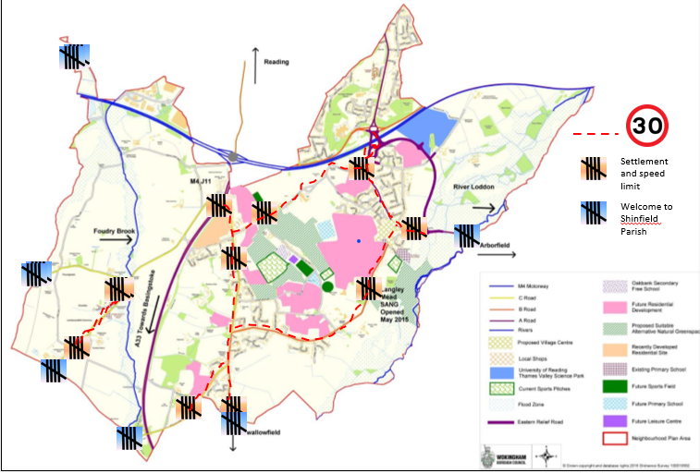

APPENDIX 5

Community Transport

Using public transport can be challenging for people with health conditions or restricted mobility.
Being able to get from A to B is crucial for maintaining a healthy, happy, active and enjoyable lifestyle.
Community Transport services help people get to where they need to go.
Three Community Transport organisations provide this service in Shinfield Parish and are given financial support by Shinfield Parish Council.
- Readibus

Tele: 0118 931 0000

Website: www.readibus.co.uk

ReadiBus is a Registered Charity founded in the early 1980’s to provide a community transport service for the residents of the boroughs of Reading, Wokingham and West Berks.

Funding

Funding is through community grants from local authorities and through individual fund raising and legacies
Driver Training

Staff and volunteers are trained in safety procedures and other routines that are essential to the provision of a safe and dependable service.

Vehicles

ReadiBuses are extra-long-wheelbase Mercedes Sprinters with a passenger lift at the rear to enable door-to-door operation in narrow streets where there is double car-parking on either side of the street.

Services

Readibus provides a local bus service for doctor and hospital appointments and for shopping and other trips.

ReadiBus also runs a programme of excursions and day trips to shopping and seaside venues

Membership and Fees

Members must be registered.
Users with restricted mobility or carers can register on the website.
There is no registration fee.
Fares

There are no fares for local journeys. The service is open to Reading or Wokingham bus pass holders only.
There are modest fares to pay for excursions but help may be available for anyone in need of financial assistance.
- Keep Mobile

Tele: 0345 544 0850

Website: www.keep-mobile.org.uk

Keep Mobile is a voluntary organisation established in 1992 to provide a community transport service for the residents of the boroughs of Wokingham and Bracknell Forest.

Funding

Funding is through community grants from local authorities and through individual fund raising and legacies
Driver Training

Keep Mobile drivers and passenger assistants are trained to the nationally recognised MiDAS/PATS standard, (Community Transport Association's Minibus Drivers Awareness Scheme) as recognised by the Department of Transport and RoSPA.
Vehicles

Keep Mobile operate 16 seater mini-buses all of which have adaptable seating arrangements to suit varying needs and are equipped with passenger lifts.
Services

Keep Mobile provides a local bus service for doctor and hospital appointments and for shopping and other trips.

Keep Mobile also run a programme of excursions and day trips to shopping and seaside venues

Membership and Fees

Membership is open to anyone living in the area covered by Wokingham Borough Council, or disabled, or over the age of 70 through self-certification.

Members must be registered. Users or Carers can register on the website.

Membership fee £1.00
Annual subscription £9.00

Fares

There are no fares for local journeys by Wokingham bus pass holders.
There are modest fares to pay by non-bus pass holders and for excursions.
- Shinfield Voluntary Car Service

The Shinfield Voluntary Car Service is a Registered Charity that was founded in 2010 to provide a community transport service for residents of Shinfield Parish and patients of the Swallowfield Medical Practice.

Telephone

0118 9883400

Email: shinvol@gmail.com
Funding

Funding is through client contributions & donations plus local authority grant applications and subsidies

Driver Training

Drivers receive training from our own accredited ‘MiDAS’ trainer on giving passengers a safe and comfortable journey. Training includes an observed drive.

A MiDAS certificate is awarded on passing.

All drivers are required to be DBS screened (Police checked)

Vehicles

Drivers use their own cars. Some vehicles are suitable for carrying portable, folding wheelchairs.

Motor insurance, road tax and MOT certificates are inspected annually.

Services

SVCS provides a door-to-door car service to help eligible clients get to medical practice and hospital appointments, to go shopping or to go on social trips such as to clubs, hairdressers and libraries.

Anyone needing help getting into and out of cars (beyond a steadying hand) will need to bring their own escort, at no extra cost.

We regret that we’re unable to push clients in their wheelchairs.

Membership Fees

Clients must be registered with the Shinfield Car Service. There is no registration or membership fee.

Fares

Most medical trips are free of charge for Wokingham Bus Pass holders.

Otherwise, we ask for a contribution of a few ponds towards running costs for each return trip made.

