To all members of Shinfield Parish Council

Notice is hereby given and you are summoned to attend a meeting of the Full Council on WEDNESDAY 2nd August 2023 at the School Green Centre, commencing at 19.00

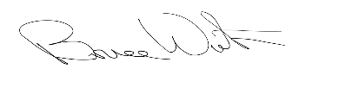
Bruce Winton, Parish Clerk
27th July 2023

Members: Cllrs Boyer, Clarke, Grimes, Jahromi, James, Jones, Lias, Masseron, Montgomery,
Peer and Tatla

Agenda
- School Transport Support from Shinfield Parish Council
1.1 | To RECEIVE and CONSIDER options for supporting School Transport for school year 2023/24 and beyond

- Dates of Next Meeting
2.1 | The date of the next Full Council Meeting will be Wednesday, 23rd August 2023

