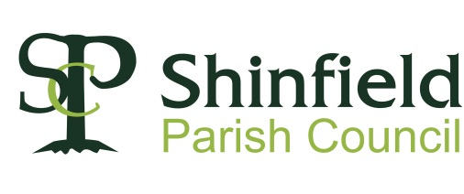

Grant Award Application Form for Young People– 2025/26

The boxes will expand to fit all your response. Please complete all boxes where you see X

Please note that the maximum amount for any grant awarded under this scheme is £150. Should you wish to request a grant for above that amount you must contact the Clerk directly – do not use this form

Core Information
Name of Young Person requesting the grant
X
Amount of Grant Requested (up to £150)
X
Summary of grant purpose (we will ask for more information later in this document)
X

Contact Information (this is who we will communicate with regarding this application)
Name of appropriate adult if applicable
X
Unless specifically agreed, email will be the principal method of communication

Information about this Specific Application
Tell us what you would like to do
X
Have you carried out this type of activity elsewhere and if so, what was the outcome?
X
What may stop you from achieving these outcomes?
X
What other sources of funding have you received for this activity or are in the process of applying for?
X

Declaration
I apply for Grant Award funding from Shinfield Parish Council on behalf of myself
Name of young person
X
I confirm that:
- I confirm that the information I have provided is accurate
- I have noted the terms & conditions under which grants are awarded by Shinfield Parish Council
- I confirm that if successful, I will comply with the grant conditions

I understand that any grant or such part as Shinfield Parish Council may determine, will be repaid if:
- The grant ceases to be used for the purpose(s) for which it was given

Full Name
X
Signature (please include in box below)
Date of Application
X

INFORMATION TO BE REDACTED – This information is required for the application process but will not be made publicly available
Address to be used for correspondence
X
Email
X
Telephone Number
X
Unless specifically agreed, email will be the principal method of communication

Now return the complete form and any attachments in an email to Clerk@shinfieldparish.gov.uk

Data Protection:
The information provided on this form will not be used for any purpose other than that pertaining to the process and consideration of your application. The personal data supplied on this form together with other information will be held securely by the Shinfield Parish Council. However, the Grant Recipient gives its consent for Shinfield Parish Council to publish the Grant Application and/or agreement in any medium in its entirety (but with any information which is Confidential belonging to the Council, or the Grant Recipient redacted) You may have access to your personal information upon request.

