SPC Newsletter May 2025
If the view of this newsletter isn't right for you, click on the three dots (top right hand corner) and select 'accessibility view' if this doesn't work in your browser, contact info@shinfieldparish.gov.uk for a PDF version.

VE 80th Anniversary Celebration & Beacon Lighting on 8th May 2025 at 8.30pm


A shared moment of celebration!
Shinfield Parish Council in collaboration with Shinfield Community Church and St. Mary's Church, invite you to join in to remember and celebrate VE80th anniversary.
Meet 8.30pm at School Green War Memorial, followed by parade led by Reading Scottish Pipe Band to The Ridge (by Deardon Field) then at 9.30pm the Beacon will be lit 'Flames of Peace: A Global Tribute!'
Finishes at 9.35pm
We have also invited local schools to use the beacon for any events they are holding.

No need to let us know you’re coming, although, we do have a facebook event if you wanted to mark your attendance there Click here

Updates from your Parish Council & dates for your diaries

Easter Friday Funday - another successful collaboration with Wokingham Partners

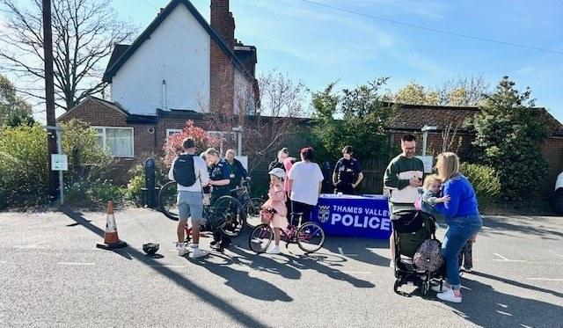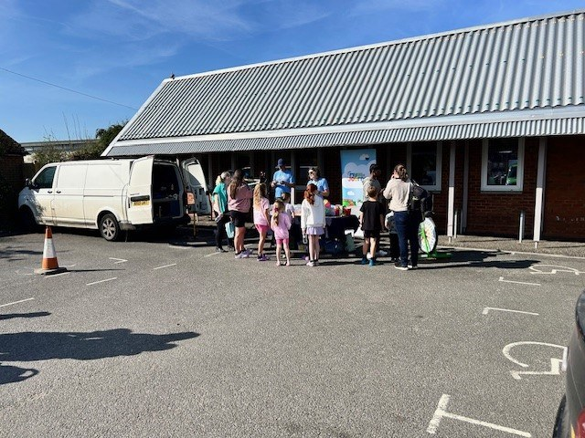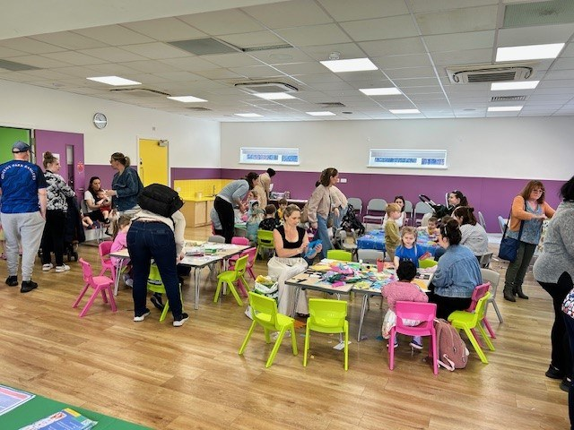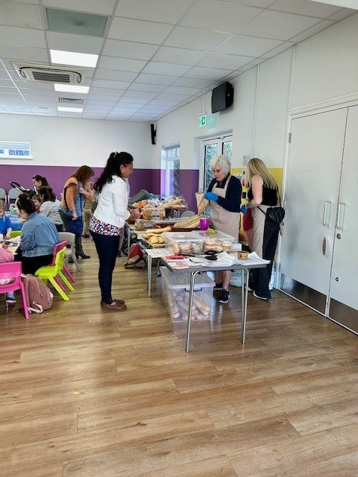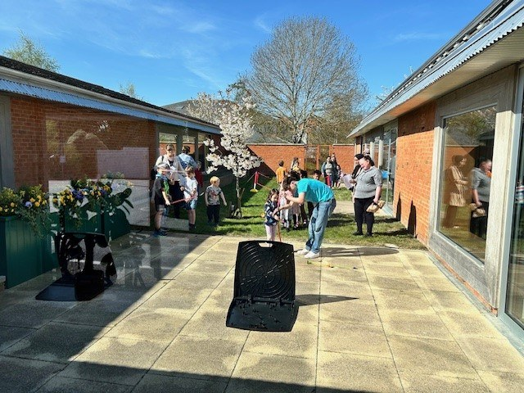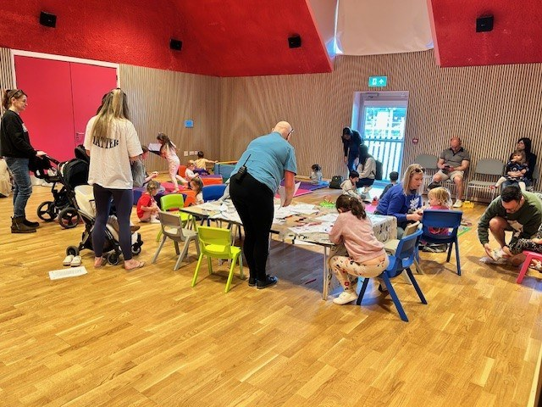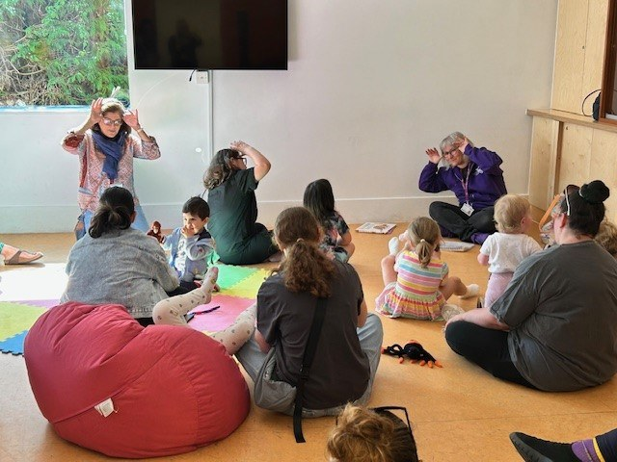
On Friday 11th April 10-1pm, we again collaborated with Wokingham Borough Council's (WBC) Shinfield North Engagement Team to bring lots of extra activities this Easter.
As well as the usual soft play and arts and crafts, lot of WBC partners supported this event;
WBC Engagement provided play dough tables and arts & crafts and organised partners to attend;
- Wokingham Library Service ran a Rhymetime session.
- My Journey Wokingham & Dr Bike were full with bike check bookings, some of the kids also made smoothies using the exercise bike!
- Thames Valley Police were busy speaking to the community and bike marking.
- SHARE Shinfield were here giving advice and handing out free food.
- INVOLVE & WBC Adult Education gave out advice on volunteering and training courses, they also had lots of sign-ups to their newsletter
Over 200 people from the local community attended at some point throughout the session. It was great to see so many of you.
Friday Funday will be back May half term.

Shinfield Parish Annual Community Litter Pick 2025
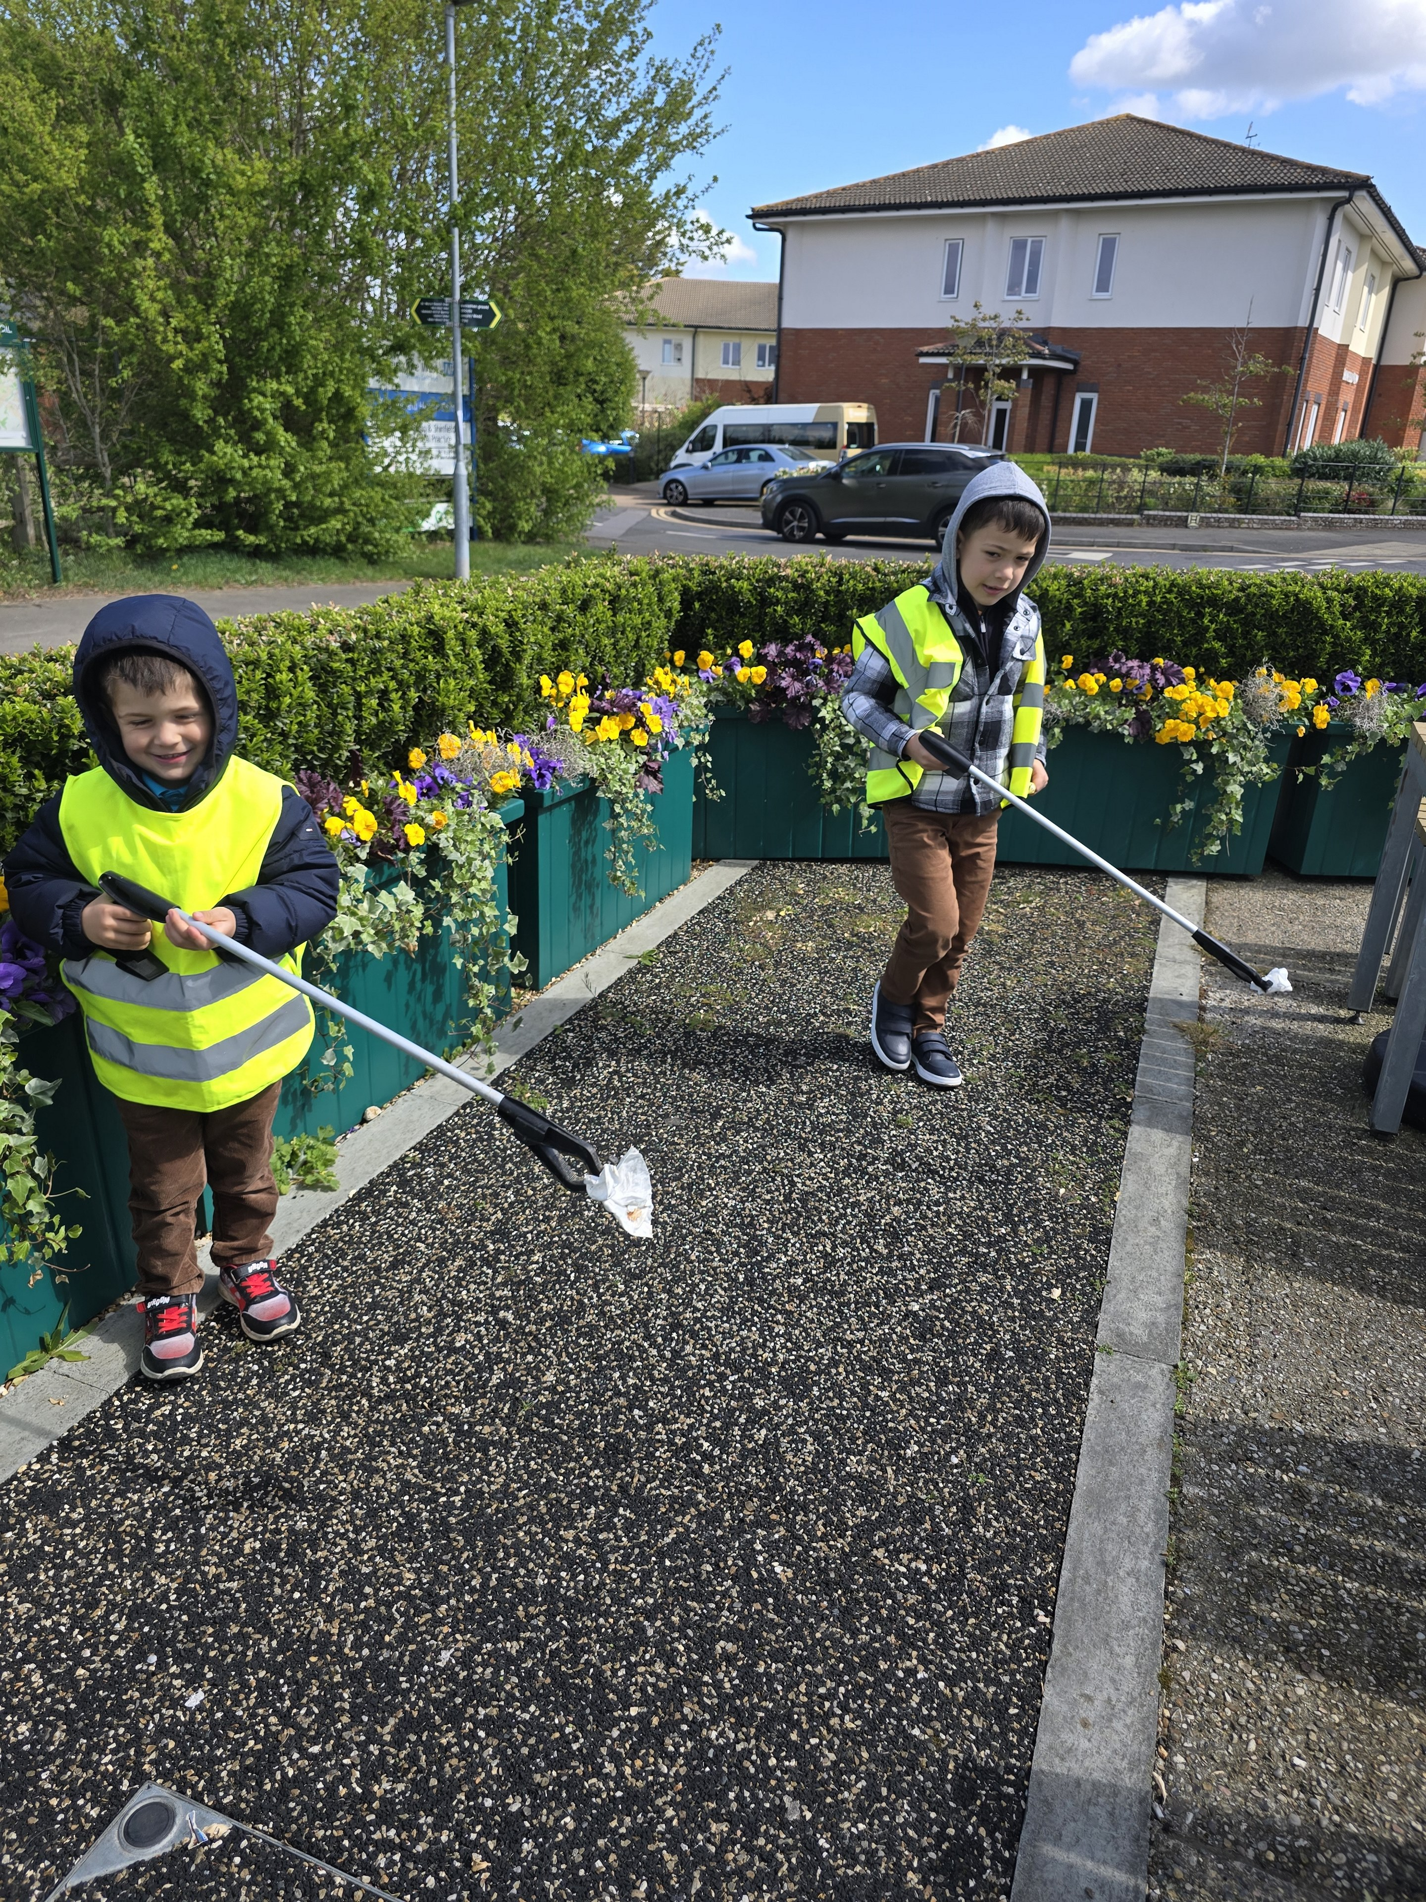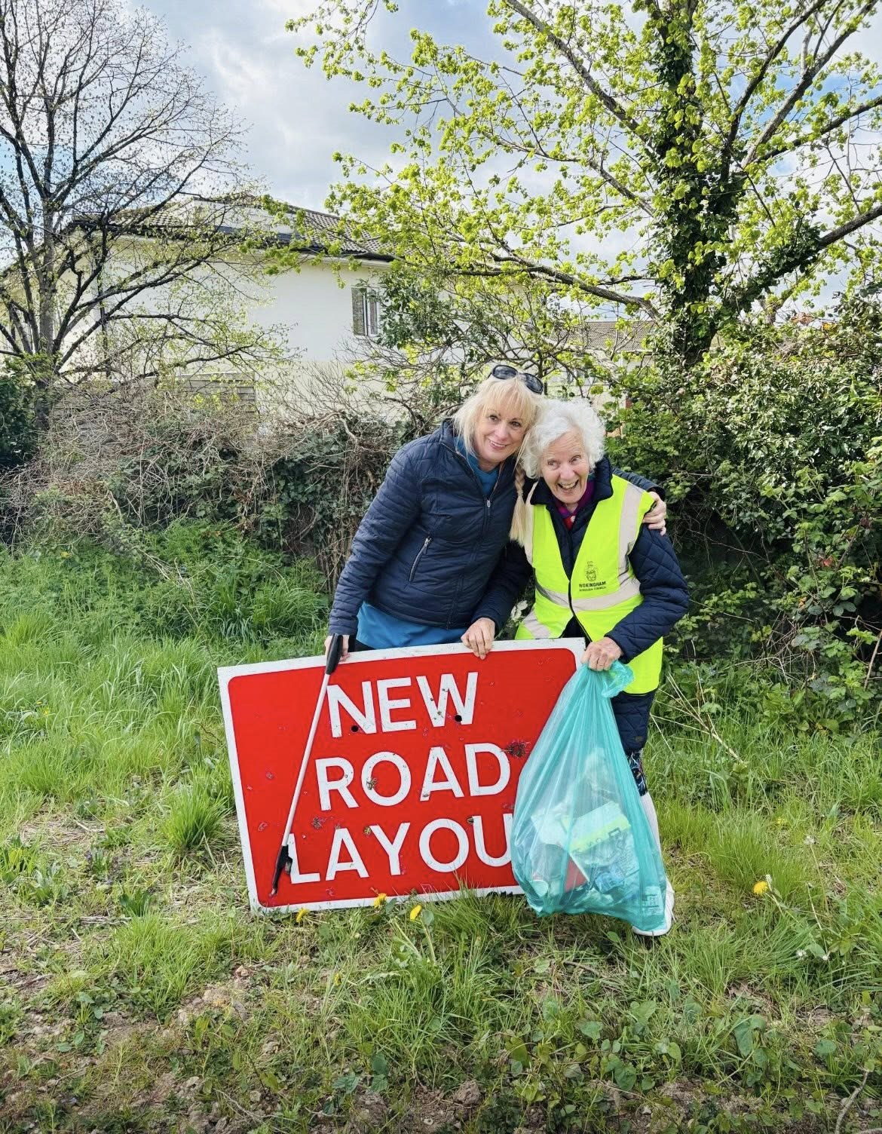
On the 16th April, Shinfield Parish Council held the annual community litter pick, aiming to collect litter from all around the parish, creating a cleaner environment for everyone and get the community involved with the Adopt-A-Street Scheme.
Shinfield View Care Home again supported the event and kindly provided delicious pastries for the litter pickers to enjoy after going out, some of their residents even got involved too!
Some families got involved too and certificates were handed out to any children who litter picked. We also laid on a Funday afternoon too, from 1-3pm, where we provided soft play and a free showing at Shinfield Cinema.
MP Yuan Yang, also supported the litter pick this year and got struck in, she brought along students from Reading University to help clean up the parish.
The amazing volunteers combined managed to collect over 12 bags of litter which is now off our streets and recreational areas.
There was also a prize for the most litter collected, this went to two volunteers who were delighted to receive the £25.00 voucher.
We want to thank everyone who got involved to help keep Shinfield Parish clean! #Prideinourparish
If you are interested in our Adopt-A-Street Scheme, or want to organise your own event, please contact Francesca.lane@shinfieldparish.gov.uk

Dates for your diaries
- Shinfield 10K - some road closures to note - Monday 5th May
- VE 80th Anniversary Celebrations 08th May 2025 at 8.30pm
- Annual Council Meeting 28th May 2025
- Annual Parish Meeting 20th May 2025
- Shinfield Voluntary Car Service AGM 12th June 2025 at High Copse Pavilion - more information to follow in June's edition. Guest Speaker on dementia.

Overview of April's Full Council Meeting
We thought it would be a good idea to give the key points from our monthly Full Council Meetings.
Full Council 23rd April 2025
1. Millworth Recreation Ground and High Copse: The outline business case for the redevelopment of Millworth Recreation Ground and the addition of a 3G pitch at High Copse was discussed. The business plan includes reaching agreements with the University of Reading, obtaining relevant planning permissions, and securing finance from the Football Foundation. The Fitness Centre element of the plan at Millworth Recreation Ground will commence ahead of the overall plan.
2. Public Art Presentation: Arts4Wokingham gave a presentation on the benefits of public art, which was a prelude to an update on the public art project. The project has a detailed timeline with key stages including the launch in May 2025, shortlisting artists by late September 2025, selecting the final artist by January 2026, and installation by the end of May 2027.
3. Crumbs Café Lease: The lease for Crumbs Café at the School Green Centre was approved. The café has been operating under a Licence to Occupy, and now the full lease will be signed. Additionally, funding was approved for the installation of a hatch between the kitchen and the café.
For information about our Committees and Full Council, agendas/minutes and supporting paperwork, visit Committee Meetings - Shinfield Parish Council

Venues for hire
In addition to our facilities at the School Green Centre and Spences Wood Pavilion, we now have available rooms at High Copse Pavilion and Manor Ground Pavilion.

MANOR GROUND PAVILION available for 'Regular' Hire only
Manor Ground Pavilion, off Garret Drive, Shinfield
- Monday to Friday 9am to 5pm - available for regular hire
Lots of parking
Exclusive hire
Accessible facilities
Competitive rates
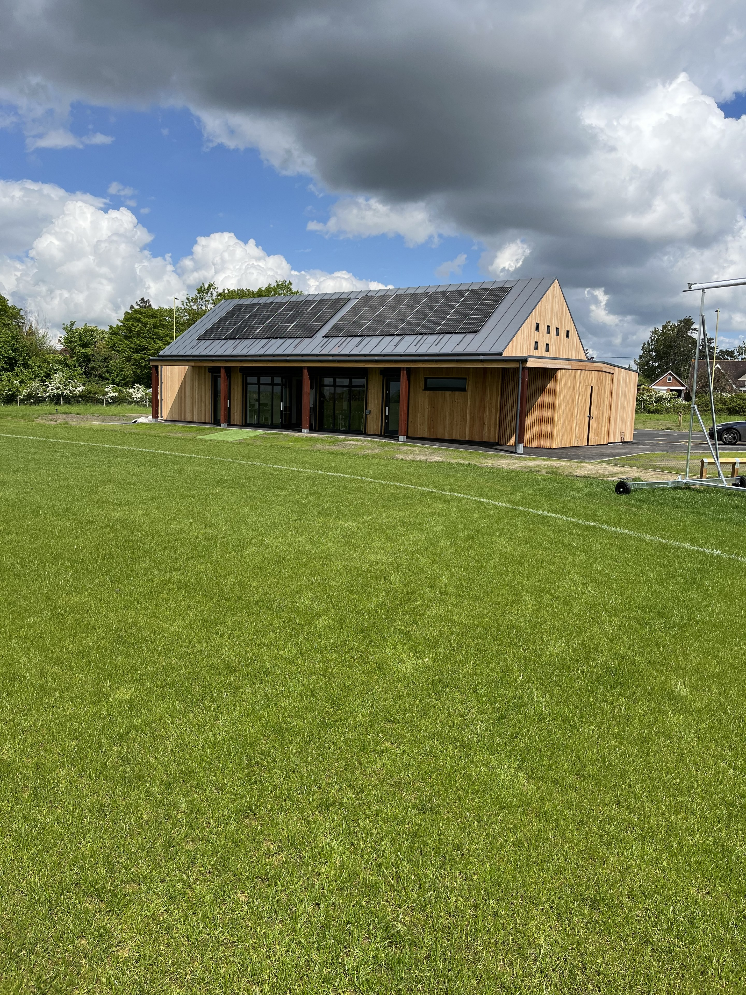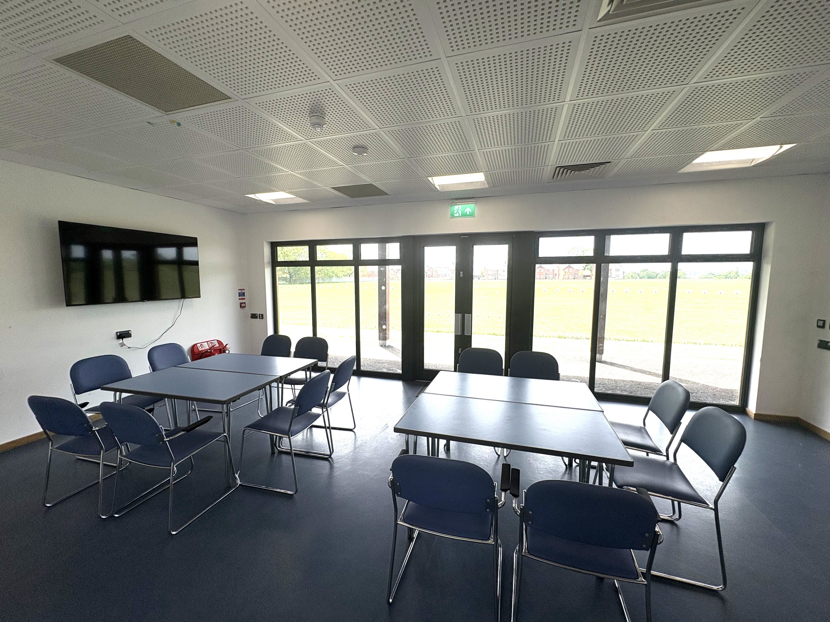

HIGH COPSE PAVILION available for hire
High Copse Pavilion, off Bolton Drive, Shinfield
- Available for regular hire Mon-Thurs 6-10pm ongoing
- Fridays 9am-10pm ongoing
- Weekends 9am-10pm up until September 2026 (when Football pitches are ready to use)
Lots of parking
Industrial kitchen with hatch (can be hired, on its own, by arrangement)
Accessible facilities
Competitive rates
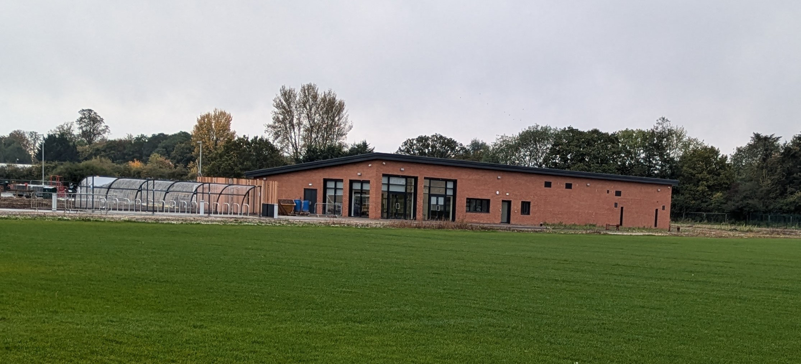
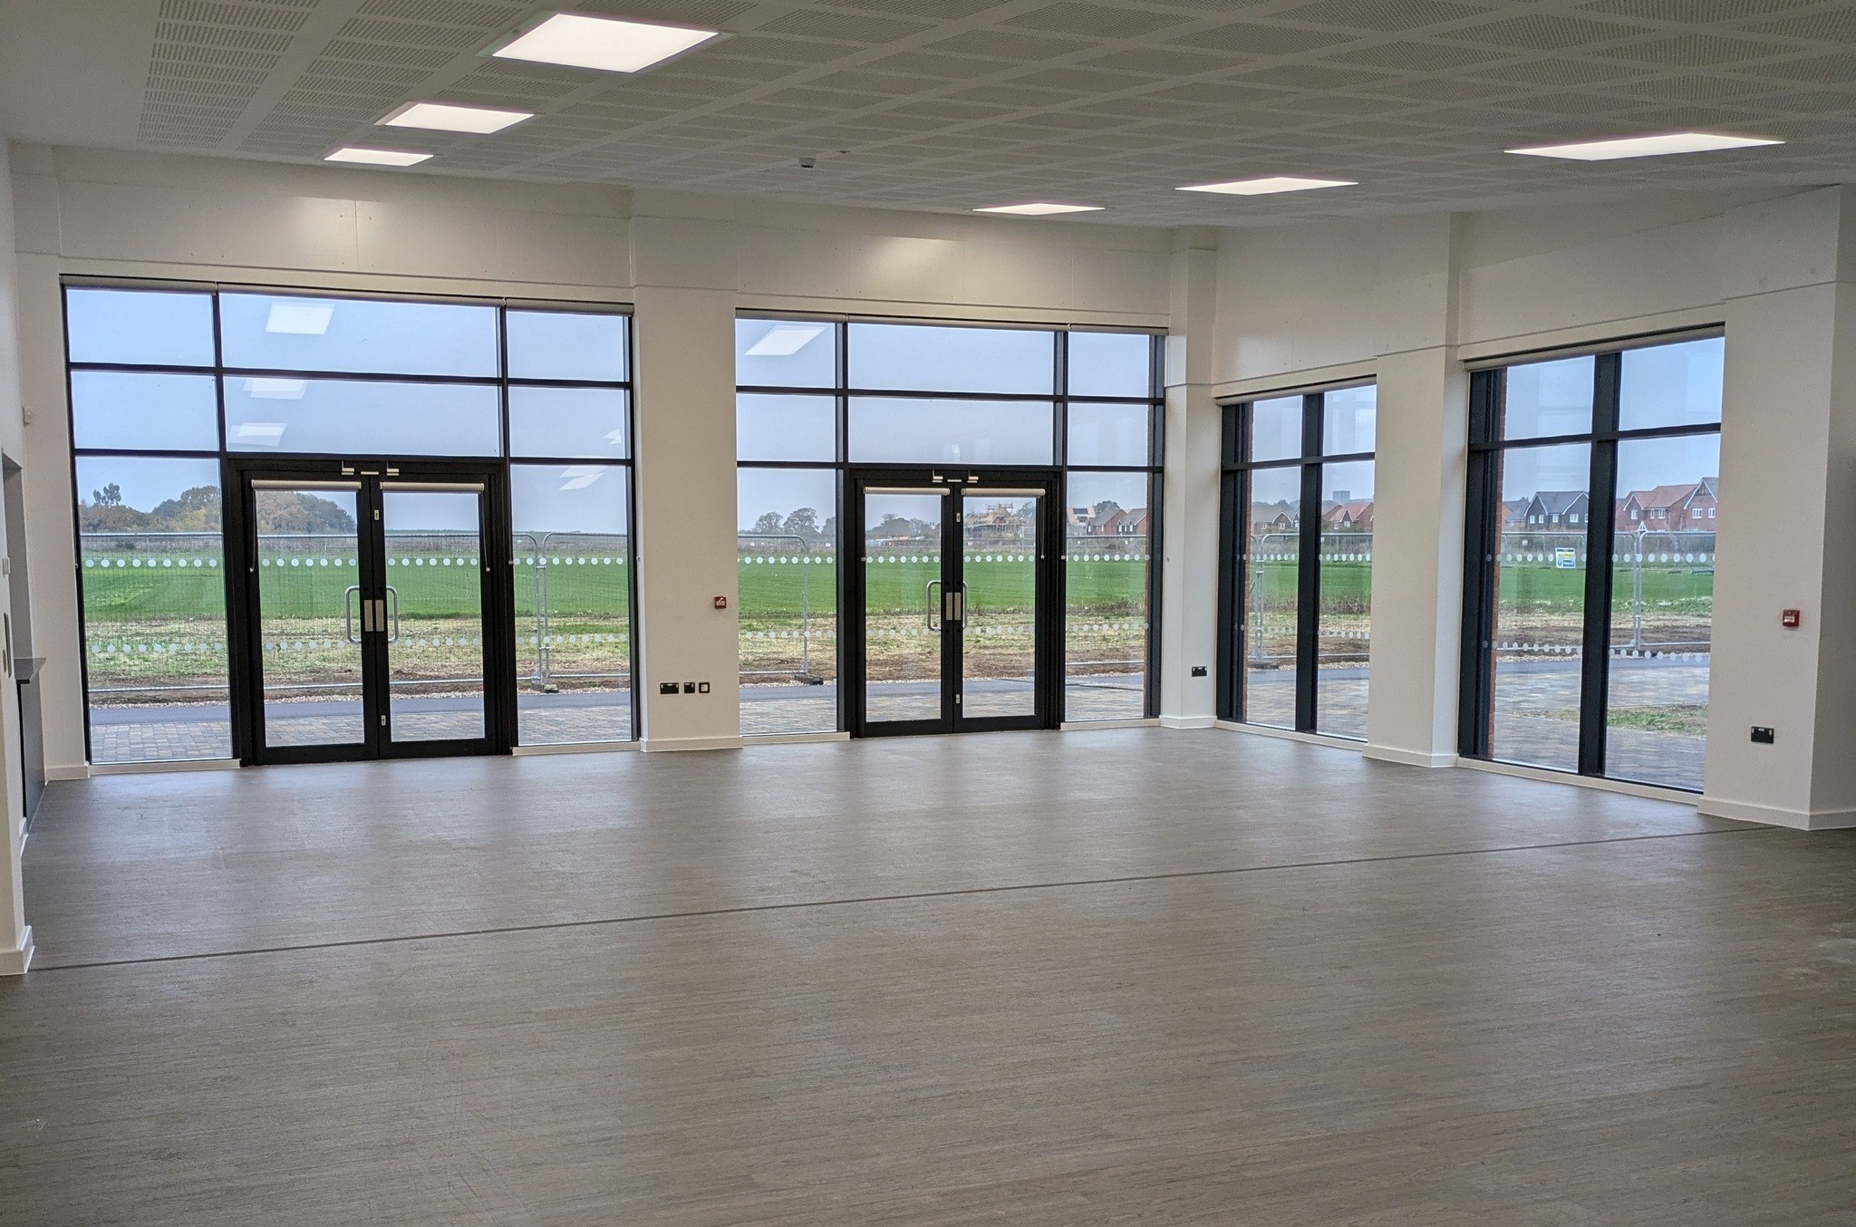
For further information on any of our venues and to arrange a viewing, please contact bookingenquiries@shinfieldparish.gov.uk or call 0118 988 8220 option 1

Shinfield Cinema - May Showings

Shinfield Cinema listings throughout May are all WW2 themed to align with VE80th Anniversary Celebrations - Shinfield - see the flyer below for all the scheduled films.
Get your tickets for here https://wegottickets.com/ShinfieldCinema or scan the QR code.
Join the Shinfield Cinema Facebook Group to keep up-to-date on all showings.



Shinfield 10k & Junior Races - Bank Holiday Monday 5th May 2025

This coming Bank Holiday Monday!
Visit https://readingroadrunners.org/races/shinfield/ for more information on all the races taking place and road closures that may affect you.
Good luck to everyone running and taking part.

My Journey Wokingham Our Adult Cycle Training for Beginners is back at a new venue
Starting on Saturday, 24 May at 10am to 11am at Alder Grove Primary School, Shinfield.
These sessions are suitable for beginners or those who haven’t been on a bike for a long time.
The sessions focus on learning the basic skills of cycling. You can borrow a bike but you need to provide your own helmet.
The session costs £11.00 – find out more or book here
https://www.myjourneywokingham.com/…/adult-cycle…

WBC Press release: Memorial woodland gathers pace ahead of opening later this year
MEMORIAL WOODLAND GATHERS PACE AHEAD OF OPENING LATER THIS YEAR
The Covid Memorial Woodland in Finchampstead is continuing to take shape, with a view to opening to the public later this year.
Wokingham Borough Council worked with the community to bring the project forward, with around 6,700 trees having been planted at the site, creating a lasting tribute to those lost during the pandemic.
Recently, council leader Cllr Stephen Conway, Borough Mayor Cllr Adrian Mather and Wokingham MP Clive Jones visited the site with a representative from The Woodland Trust. The creation of the Covid Memorial Woodland has been made possible with the support of The Woodland Trust's Emergency Tree Fund.
Wildflower seeding will take place later this spring and summer. Additionally, the council plans to install footpaths and signage to help residents visit the woodland in the future.
A symbol of hope
Cllr Conway said: “It was an absolute privilege for us to be able to share this experience with our residents. More than five years on from the outbreak of the pandemic, we have not forgotten how hard a time it was for everyone and it is important to have somewhere that people can go and reflect and remember their loved ones.
“Thanks also to the support of The Woodland Trust, we have an opportunity to create something that will stand as a symbol of hope for our borough, as the pandemic brought out the best of us in terms of community spirit and helping others at a time of great need.
“I look forward to seeing how the woodland takes shape and supports our ongoing effort to plant trees across the borough to tackle the climate emergency.”
About 1,000 of the trees were planted at eight community sessions, which were held from Wednesday 19 to Saturday 22 March. There are 17 different species, including hazel, English oak and wild cherry, with the aim of replicating existing species nearby and to help biodiversity flourish.
The sessions were attended by about 170 people, who were assisted by the council’s Countryside Services Team.
Tree Cities of the World
Earlier this year, Wokingham Borough Council was awarded Tree Cities of the World status for its work in urban forestry. It was one of 27 local authorities to be recognised by the Arbor Day Foundation and the UN Food and Agriculture Organisation.
Jenny Scholfield, Woodland Trust Regional Director for the South East, said: "The Woodland Trust's Emergency Tree Fund was designed to support local authorities delivering ambitious tree planting goals, to help meet the challenges of climate change and nature loss. Planting trees is a great investment for a more resilient future.
"The Covid Memorial Woodland is the final part of a three-year tree project. With it, Wokingham Borough Council and the local community have created an inspiring legacy for lost loved ones and a haven for both people and nature for generations to come. The Woodland Trust is proud to have supported this initiative."

Shinfield Volunteer Group Footpath Report - April 2025
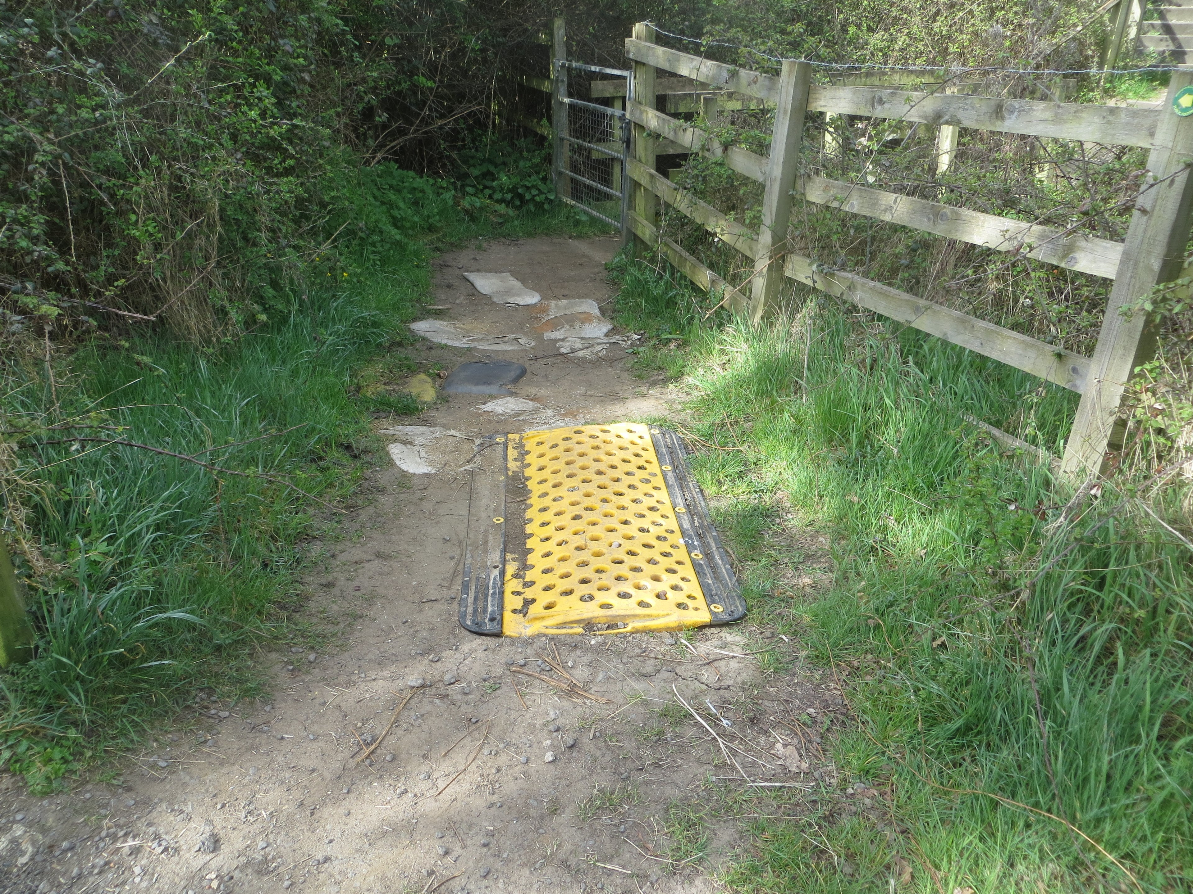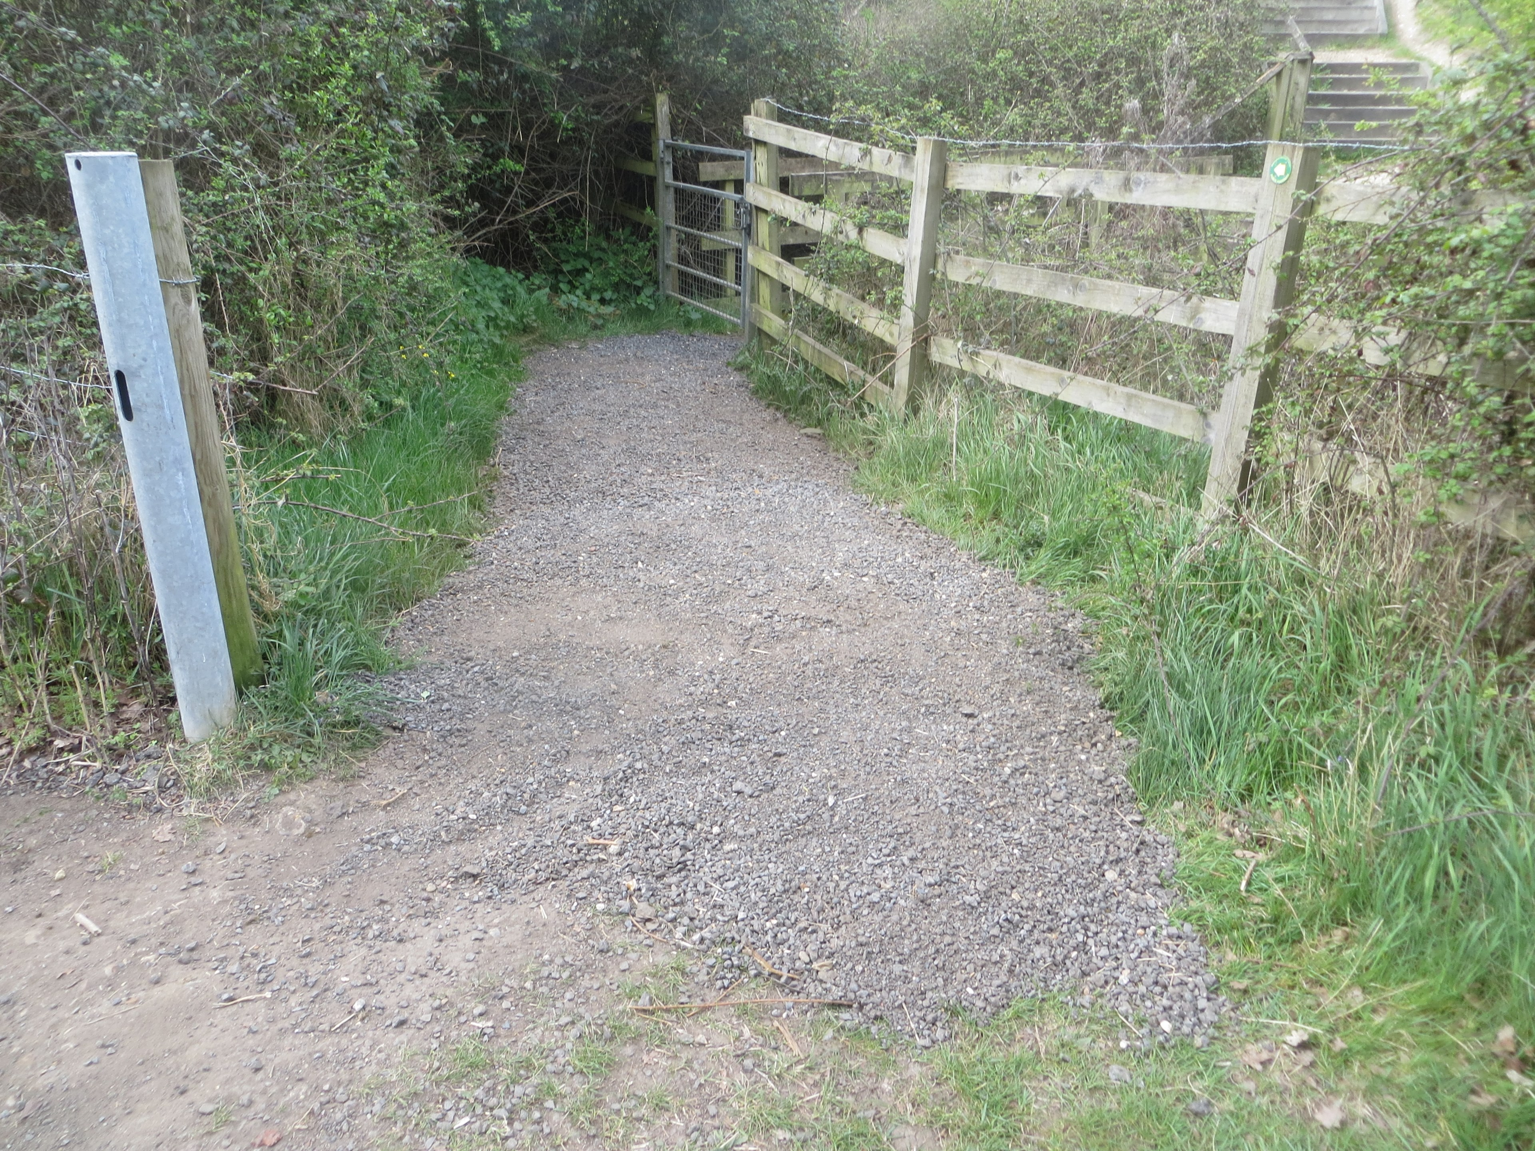
Welcome to all our readers. It has been busy month ending up with our April footpath report.
Pearmans Copse
As predicted last month we revisited the top end of Pearmans Copse. In the event there were just two of us but we managed to deal with some errant bramble leaders. It had also been noted in March that the seasonal pond was high enough to make passing difficult. We rectified that by cutting the foliage line a little bit up the slope. The whole of Parish Walk number 6 was then checked and found to be in good order. It may be a bit late now but there was a magnificent display of Bluebells in Nores Wood.
Reading 13.
The first few metres of this footpath at the bottom of the steps from the A33 is very important for a number of users but particularly for students walking over the M4 on their way to Oakbank School. This little section was a bit low and collecting water. Some well meaning souls had placed various objects to form stepping points. One of our volunteers joined me and we filled the depression with some road shavings. There are before and after photos for you interest.
Shinfield 28.
Quite an important little path this one running from the northeast in Leyland Gardens, southwest to Hollow Lane. One of our footpath monitors alerted us to stinging nettles and overhanging foliage. We strimmed the nettles and removed some of the overhanging foliage. That still leaves a bit more to do but that will happen during May.
Also along this footpath at the junction of the very old link to Leyland Gardens but recently designated a definitive public right of way there is an issue with high foliage blocking out the street light as it shines down. A number of residents have asked if we can do anything about this so we have asked advice from WBC.
If you like gardening and feel you could help as a SVG volunteer, maybe cutting a few brambles back we would like to hear from you. Our contact details are below.
Ray Sharp at ramblerray@gmail.com or 07761 251217
Elaine on 0118 988 2771

Find your next career move at free job fair 12th May 2025
FIND YOUR NEXT CAREER MOVE AT FREE JOB FAIR
Wokingham Borough residents can meet prospective employers at a free job fair being held next month.
The event is being jointly organised by Wokingham Borough Council and the Department for Work and Pensions, giving people the opportunity to speak with employers from a range of different sectors.
It will take place at the Bradbury Centre in Wokingham on Monday 12 May from 10am to 2pm. There is no need to book, just turn up on the day.
Cllr Mark Ashwell, executive member for Economic Development, Sport, Leisure and the Arts, said: “I am pleased to share that Wokingham Borough Council is running another job fair in the heart of Wokingham. We are delighted to welcome a range of employers and support organisations, who will all be bringing a variety of local jobs and training opportunities.
“While we are fortunate to have an enviable local economy, we mustn’t forget those who are unemployed or who are struggling with the cost of living. We hope that by providing this free event for our residents, we can help connect local people to local jobs.
“We’d like to thank all employers and partners who are supporting and taking part in this job fair, without their support we would not be able to deliver such events. If you are someone who is looking for a new job, seeking help with training or want to explore changing career, please come along. There is no need to book and everyone is welcome.”
Attendees will be able to speak to employers from construction, care, hospitality, local government, the film industry and more. They will also be able to access information on training and apprenticeships, as well as help with writing a CV and searching for jobs.
Most of the jobs are with local companies and organisations and do not require extensive travel.
Several employment support organisations will be providing tailored career advice or referring residents to the best places for job-related information. Resource Productions, a social enterprise that champions diversity in film and televisions, will take part to shed light on these fast-growing industries.
The council is also looking to invite employers to participate in this free event by reserving a table.
Alongside employers, there will be support from training providers, our local job centre and other support services, making this a one-stop shop for residents and businesses looking for their next job opportunity.
As a local employer, the council will be discussing and answering questions from residents about apprenticeships and opportunities in the area.
For more information or if you need assistance on the day, please email the council’s Economic Development Team. 0118 9746000

Royal Berkshire NHS Foundation Trust are refreshing their Trust Strategy

Our Trust Strategy outlines our vision and is our plan of action to achieve our goals and objectives. We want to hear from you to help shape our strategy and make our future decisions.
Tell us what you think
Our Trust Strategy will be created together with our patients and community, our staff and volunteers, and our partner organisations. Together, we can make sure Our Trust Strategy reflects the voices and needs of our local communities.
Get involved:
- Online - You can fill out a survey online to share your ideas.
- By post - If you would prefer to write to us, please send all post to: RBFT Strategy Team, Princes House, 73A London Road, Reading, Berkshire, RG1 5UZ

WBC Community Safety and Enforcement Bulletin 28.04.25
https://content.govdelivery.com/accounts/UKWOKBC/bulletins/3dd38a6

What's on in the Parish & locally







For more information on what's on locally visit www.shinfieldparish.gov.uk/what’s-on

School Green Centre, School Green, Shinfield, RG2 9EH
0118 988 8220
www.shinfieldparish.gov.uk

